Project Summary:
Streamline is a predictive analytics/web app system designed to forecast how crowded Dubai Metro trains (and stations) will be at particular times (e.g. specific hours, peak vs off-peak), using historical ridership + contextual factors like nearby events, weather, holidays. The output will include estimates such as how full a train or station will be (e.g. “80% full”, “crowded”, “light load”) and possibly breakdowns by coach (which coach likely to be more crowded). The user interface allows commuters to check upcoming crowding, plan when to travel, or choose alternate routes/stations to avoid crowds.

Unique Points:
- Novel Prediction of Load / Coach-level Crowding: Many transit apps show schedules and time taken for a ride, but they do not predict how full each train, or even each coach/car, will be ahead of time, especially with event/contextual inputs. The selling point will be the coach-level prediction (which is affected by the location of the elevators and escalators and quick studies that can be done in a few stations) + contextual awareness (event, weather, maybe special holidays) which adds intelligence beyond just ridership over time.
- Suggestive Routing / Behavioral Nudges: On top of predictions, offering intelligent suggestions (e.g. “If you leave 5 minutes later, you will avoid peak load”, or “Walk from Station A instead of Station B, or board from the front/middle coach for less crowd”) adds a UX/business-value dimension.
- Highly Localized Model / Customization: Tailoring the model to Dubai Metro (stations, metro lines, event culture, peak hours etc.) rather than generic transit forecasting. That gives localized accuracy and usability.
- Dashboard / Visualization Tool: A polished UI that shows load predictions on a map or train schedule, with visualization of coach-crowding, so it's not just “backend modelling” but a product-like prototype.

Rough Milestones:
- Data Collection & Integration: Gather historical ridership data (station, line, time), collect event schedules (concerts, major public events, festivals), weather/holiday data. Possibly collect station metadata (station size, number of entrances, proximity to event venues).
- Data Cleaning & Feature Engineering
- Modeling of Load Prediction: Starting with station and moving to cabin-based prediction after conducting studies and collecting additional data.
- Handling External Contextual Inputs: Incorporate schedules of events and schedules and possibly build NLP scrape of event sources if needed.
- Adding Additional Features: Eg. Contextually aware notification for less busier rides.
- UI: Build frontend/web dashboard that shows predicted crowding by station/time (maybe by coach), possibly with map interface or station list.
- Evaluation/Validation
- Deployment

DataSets:
- DubaiPulse DataSets mentioning per day rider info along with monthly station passenger info: https://www.dubaipulse.gov.ae/organisation/rta/service/rta-rail (A few main ones are attach
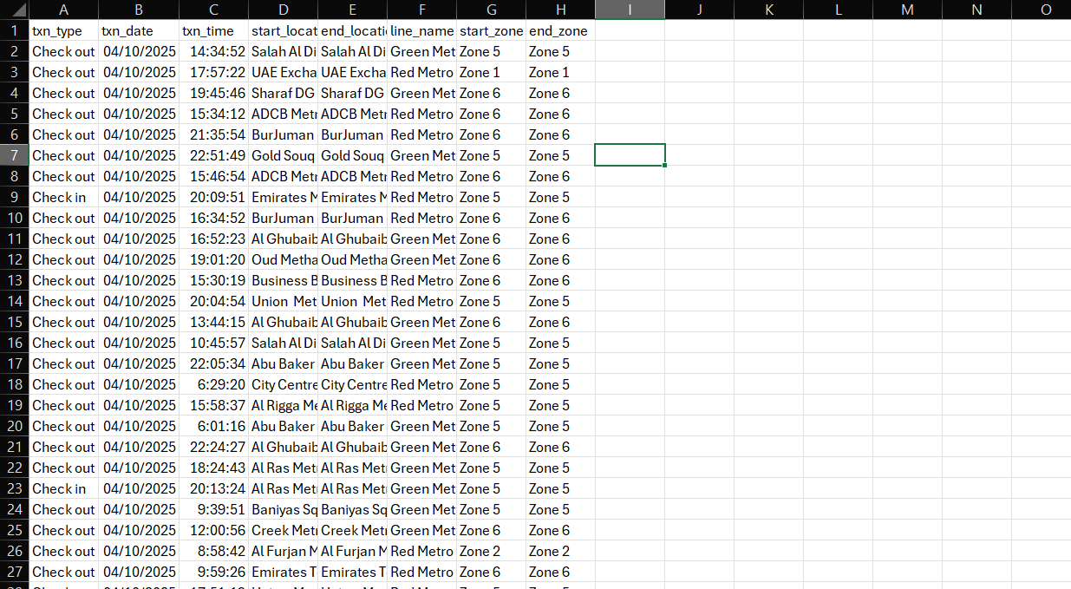
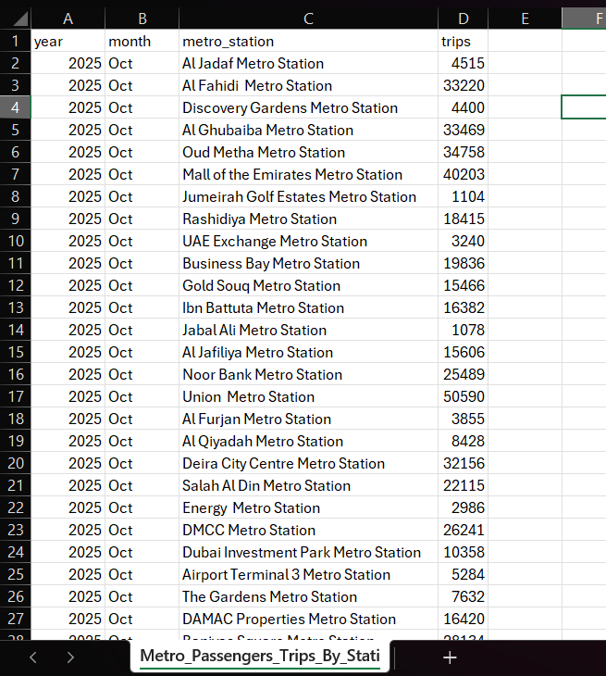
- Ridership trends were noted here - https://ieeexplore.ieee.org/document/1097185

